NWU Official Academic Opening in February 2020
Address to the guests and staff of the NWU on the three Campuses
Gaining Momentum as unitary university in 2020
Prof RJ Balfour, DVC Teaching and Learning
Introduction and acknowledgements
Mr Vice Chancellor, members of management, and staff present here, good morning and welcome to this special opening of the academic year in which we reflect on the highlights and achievements of 2019 and share directions to be pursued in our core business in 2020. Thank you also to members of the management team who provided inputs into this address, and the Vice Chancellor for making time to be with us in welcoming academic and administrative staff at the official Opening of the University. Our theme in 2019 as University was one of “consolidation”, in terms of the operational model and the alignment of systems. In 2020 we must shift energy, and so the theme of today is “Gaining Momentum” in terms of our research and innovation, teaching-learning and community engagement. Kindly allow me to begin by also thanking members of the student leadership of the University, for your presence this morning.

Our Strategy Statement is “To transform and position the NWU as a unitary institution of superior academic excellence with a commitment to social justice”. All these words will be familiar to all members of staff, please take them to heart so that if at any moment it seems to you that you are feeling lost, or that we have lost direction, that these words become your map to the stars for 2020. What are we doing? We are transforming the University. How are we doing it? We are positioning ourselves as a unitary institution. Why are we doing this? We are committed to academic excellence and social justice in our academic project. Excellence and social justice are integrated concepts. All our efforts as University are geared to supporting student success and the extent to which we develop our academic and administrative staff to ensure the future success of our university, is commensurate with our awareness that our students are the future of our beloved country. Overarching of all our efforts at achieving synergy of systems support in the three areas of our core business as well as our administration is the development and implementation of our Digital Business Strategy in 2020.

2020 has had a troubled start at Mahikeng owing to the late resolving of issues between the DHET and the student body nationally. Nonetheless as registrations are being finalised for contact as well as distance students alike, it seems as though we will easily reach our targets for new and returning students. In 2019 NWU had just over 64 669 (not final) students enrolled on its three main campuses, Vaal Triangle, Mafikeng and Potchefstroom, with the overall target for 2020 being 63 065 students. The following information is worth bearing in mind as we start the academic year.

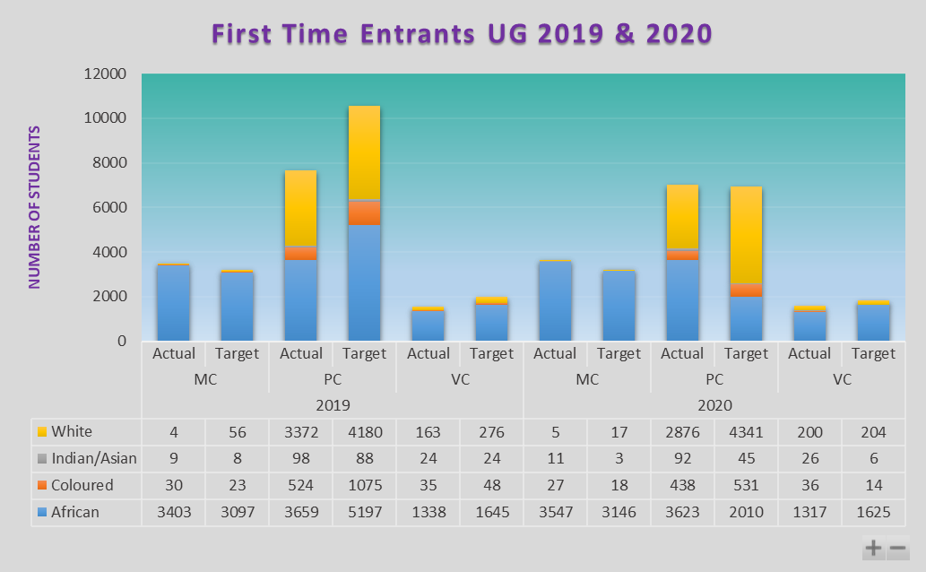
Table 1: FTE Actual and Planned Enrolments as at 31 Dec for 2019 and 31 Jan for 2020 (Contact & Distance)

In terms of race distribution for 2020, African students accounts for 69% of actual First Time Entrants UG enrolments, followed by White students at 25%, Coloured students at 4% and Asian students at 1% (in both contact and distance programmes). Thus far, NWU have reached our 2020 target for undergraduate contact First Time Entering students.

Contact FT Entrants UG per Race 2020
Year | Race | Actual enrolments | Target enrolments
2020 | African | 6 452 | 5 421
 | Coloured | 401 | 313
 | Indian/Asian | 103 | 23
 | White | 2 755 | 3 952
Total |  | 9 711 | 9 709
Table 2: FTE UG Contact Enrolments as at 31 Jan for 2020
When we glance at our preliminary FTE numbers per faculty we note some over enrolments in the Faculties of Natural and Agricultural Sciences, Humanities and Theology. Enrolments are on or close to target in the Faculty of Engineering, Education and Health Sciences. Overall, what bears noting here is that alignment with the University Strategy of emphasising the SET skills associated is steadily coming into place.
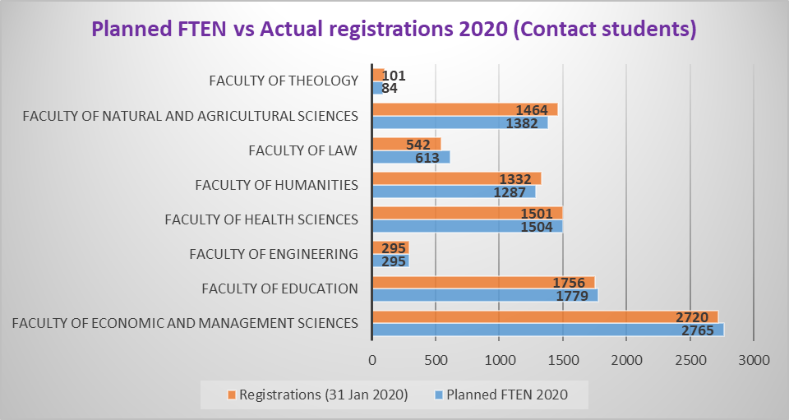
Table 3: Actual vs Target First Time Entering contact students (as at 31 Jan 2020)

This leads me in the next section of my talk focussing as it does on research and innovation achievements in 2019 and foci moving into 2020.

The Research and Innovation Project at NWU: 2019 achievements and new initiatives in 2020
We remain one of the top 7 institutions in South Africa in terms of research outputs; the only institution without a medical school in this category. In 2018 we registered 1497.96 published research outputs units. The University was ranked the 6th institution in South Africa in 2019 (our total number of NRF rated researchers in 2019 was 270). In 2019, 27 new ratings and 18 renewed ratings were achieved, and by the end of the year we had graduated 146 PhDs and 262 Masters graduates. So far in 2020 we have accepted 185 PhD and 822 Masters students, boding well for ongoing research outputs for this coming year. Also in 2019, 84 National and International Research Awards were awarded to members of the NWU staff and R40 702 200 IREA awards (based on 2017 output) were paid to 1493 researchers in 2019 - a fact affirmed by the NWU being ranked in the top 5 universities in South Africa by the Times Higher Education World University Rankings.

NWU boasts with 12 Research Chairs, the latest being the DST/NRF Albertina Sisulu Research Chair in Nursing Science (SARChI). Of the 40 research entities of the NWU, 9 were internally evaluated in 2019. NWU continues to occupy critical space in the South African national science system hosting 7 national entities linked with national and international imperatives: Department of Science and Technology/CSIR Hydrogen South Africa, DST/NWU Preclinical Drug Development Platform, DST Indigenous Knowledge Systems Centre, the Department of Trade and Industry Centre for Advanced Manufacturing, the South African Centre for Digital Language Resources (SADILAR), DST Metabolomics Platform all of which continue to enhance research and innovation excellence, visibility, and impact. The University also hosted 9 high-level public lectures in 2020 as part of the DVC’s initiative to strengthen NWU visibility and national and international networks, and the first University Lecture on Academic Freedom; a lecture which will be offered annually. NWU Research Day took place in Mafikeng, during April 2019, to inspire a vibrant research culture for all faculties.

In terms of capacity development approximately R1m of our UCDP funds was provided to staff to complete their postgraduate studies and we hosted 14 DST/NRF internships across all faculties for 2019; 231 postdocs were hosted; our annual postdoc conference took place with great success.
In 2020, we will focus specifically on support strategies for improved academic integrity, in conjunction with research productivity. Academic integrity is not simply related to research, but extends to all our processes and practices as support and academic staff, and so it is important in our work going forward that we protect the University by observing its processes concerning research ethics, ethics in the classroom, and in the workplace and that we alert authorities to the risks concerning our ethics.

One of the main foci in the first half of 2020 is the preparations for the national CHE Doctoral Review. At the end of March, the Self Evaluation Report and suggested Improvement Plan, wherein the NWU has already identified certain aspects of concern, will be sent to the CHE for consideration. The actual planned visit to the NWU will take place in August. The review has as aim the assurance and alignment of high standards for the offering and conferring of doctoral qualifications across all South Africa universities.

Furthermore, 2020 will see continued efforts to create a conducive research and innovation environment by addressing workload balance, the institution of a Research Chairs Day, the launch of the NWU organization for Women in Science, as well as institutional support for new book projects initiatives that meet DHET requirements. We will support retreats/workshops as well as academic integrity-related workshops and provide faculty-based research mentorships for junior researchers to grow and publish. To improve our visibility and impact, we appeal to all academic staff to ensure that they are ORCID registered, have scopus profiles, prioritize publications in scopus accredited journals; and engage in bibliometric benchmarking and strategies to improve our research status.

Finally, the International Atomic Energy Agency visited the Faculty of Engineering recently to do an external programme evaluation for possible international recognition and accreditation of the postgraduate degree in Nuclear Engineering and Management. The outcome of this process will be made known by mid-2020 and, if successful, the NWU will be one of only a handful of Universities world-wide with such international recognition. This will place the NWU in an ideal position to train nuclear engineers from all over the globe, fitting into the recent announcement by the South African government that it is still committed to have nuclear power as a part of the energy mix for South Africa. Sustainable and renewable energy sources remain a national and international pressure as issues concerning climate change begin to affect the entire planet, and so we see increasingly a global trend for the need for stronger community partnerships for complex problem solving at a social as well as scientific level, which brings me to the next section of this address.

Community and the quality of NWU Engagement: 2019 achievements and new initiatives for 2020
UN Secretary-General António Guterres, in September 2019 made the following statement: "I am issuing a global call for a Decade of Action to deliver the Sustainable Development Goals by 2030. Now is the time for bold leadership, both individual and collective...mobilize partnerships like never before”. NWU’s strategy is to focus on sharing of our expertise/knowledge in addressing relevant community needs and to find sustainable solutions in collaboration with all stakeholders. Utilising trust relationships with communities in equal partnerships, the University is able to negotiate opportunities for students to apply their knowledge and skills in order to reach specific learning outcomes. Community engagement is the vehicle through which the university contributes to development and the attainment of the sustainable development goals.

One of the main tasks of the Unit for Sustainability and Community Impact (SCI) is to link communities' needs with the expertise available at the NWU. This unit liaises with NGOs and companies who are looking for opportunities to implement their corporate social responsibility, and assists them with community impact studies. Sustainability includes having a green campus in terms of recycling and energy efficiency awareness as we have seen with the NWU “Flipping the switch” campaign. We hope to upscale these efforts up considerably in 2020.

We endeavour to have a collective impact on the economic, social and environmental well-being of society by sharing the expertise within the University and providing capacity building not only for our students, but also with civil society. In 2019 Deputy Deans for Community Engagement and Stakeholder Relations in our Faculties have worked with us to align related community activities across the campuses. Each Faculty has formed its own Stakeholder or Community Engagement committee that focussed aligned Faculty guidelines and updating policies for Community Engagement such that these support work-integrated and service learning across the university. Student colloquia on how to become more engaged in service learning in communities were presented at the MC during 2019 and planned for the Potch and Vaal campuses in 2020.

We embarked on a food security project at local schools in the Ngaka Modiri Molema district of Mahikeng in 2019. This took the form of partnering with FNAS with the Crop Science Subject Group driving the project, and Ms Motsei Modise, an NWU alumnus, who donated generously the funding for the project. The e-Agro-Tourism Colab, a project within the School of Communication of the Faculty of Humanities, provides funding to train community members. The main aim of the food security project is to provide schools with the necessary garden tools, seeds and seedlings to start their own vegetable gardens. The schools that benefit from this outreach are Lokaleng, Signall Hill, Ramosadi, Seetsele, Lotlamoreng and Podile primary schools. In summary there were 87 student led community engagement projects in 2019, and over 250 registered CE projects at NWU involving more than 3000 students volunteering and engaged in community projects.

The University is furthermore one of only nine South African and European universities that are involved with the Common Good First campaign funded by the European Union Erasmus Plus programme. One of the main objectives of the campaign is to stimulate digital literacy and the idea of storytelling for learning in all types of communities. As this is all about the “common good” of societies, it focuses on encouraging people who have found their own solutions for challenges to share their stories. The idea behind the project is to share any kind of social innovation with the world and more especially between universities and students and create networks of shared solutions across the world.

In 2019 several academic staff members and their teams were acknowledged for their contributions in community engagement excellence during the annual Vice-Chancellors Excellence Awards. Of these we recognised the considerable contribution that has been made by the Faculty of Law in their consultation work done in the Law Clinic, the moot courts and the March Against Abuse of Women and Children. Awards were also given to recognise the exceptional role that the African Unit for Transdisciplinary Health Research (AUTHeR) play within health sciences, referring to projects such as the NWU Wellness project and COPC, which actively engages with communities through deploying the Social Greenhouse process with the support of the Community Integrated Research (CIR) office. The Faculty of Theology clearly demonstrated their ethic of care with its Fatherhood Training and Equipping Programme and its Project: A Life Beyond Iron Bars that focuses on helping families who have men/fathers in prison. Community related work, whether integrated into the curriculum, or not contributes directly to the realisation of our graduate attributes which brings me to the third section concerning teaching-learning at the NWU: 2019 achievements and 2020 directions.

The Curriculum Project at NWU: 2019 achievements and initiatives for 2020
The NWU prides itself on its performance in the arena of international and national institutional rankings. In 2019 the ranking by the Center for World University Rankings (CWUR) is indicative of the NWU climbing the ladder of world-ranked universities by improving its ranking by close to 100 positions, moving from position 964 to 869, which sees it amongst the top 4,8% of the more than 18 000 universities evaluated worldwide. Even though the NWU stays at number 7 in terms of CWUR’s ranking of South African universities, it is the local university that has increased its position the most by far.

As noted already the 2019 Times Higher Education (THE) World University Rankings placed the NWU in the 5th position in South Africa, and between 501 and 600 out of the 1396 participating universities. That being said, research into student study choice behaviours is indicative of students generally placing more value on the ranking of individual subject areas than on global institutional rankings. In 2019 the global Academic Ranking of World Universities (ARWU) where 1600 universities across 83 countries compete for rankings, several of the NWU’s academic programmes were placed in the top 100 to top 500. NWU’s Geography, Psychology and Environmental Sciences and Mathematics, among the top 500 in the world. With regard to other subject groupings, Politics and Education are among the top 400 whilst the University’s subject group Atmospheric Sciences ranks in the top 300. Furthermore, according to ARWU, the NWU excels in the subject grouping Hospitality and Tourism in the top 200 globally. Our Mining and Mineral Engineering subject area was ranked among the world’s top 100. The NWU is one of only two South African universities where both Atmospheric Sciences and Mathematics rank in the top 500. Nationally NWU shone is the SAICA Board Examination results in South Africa holding the joint number 1 position with Pretoria in terms of student success in 2019. For Humanities subjects such as Graphic Design, Languages, Linguistics, History, Philosophy and Theology, the Times Higher Education Rankings placed the NWU in the 401+ group out of 536 international universities – a significant achievement taking into account that the NWU is being measured against acclaimed international universities such as Stanford University and the University of Cambridge, among other institutions. Internally to NWU we hosted the Annual Teaching-Learning Excellence Awards event in early 2019 with some 36 recipients of various levels of teaching-learning recognition being celebrated.

Four new qualifications were registered by SAQA: The research variant of the Master of Health Sciences in Occupational Hygiene that supplements the taught/coursework variant we have been offering; the Master of Education in Environmental Education, is one of two environmental education qualifications offered in SA; the Bachelor of Nursing aligns with new professional body regulations, as required for all universities; and a 3-year Bachelor of Arts in Language Technology. These two postgraduate and two undergraduate qualifications will all be delivered in the contact mode. The MSc in Engineering Science also now includes a programme in Nuclear Engineering; and the BEd (Senior and FET Phase) in Engineering Graphics and Design will also be delivered for the first time via distance mode.

At a policy development level, we initiated and completed the first draft of the new Teaching-Learning Strategy of the NWU and plan to complete the revision for Council approval in September and implementation in January 2021. The revised Strategy will influence the revision of the Faculty’s Integrated Teaching-Learning Plans: on the importance of preparing our students for transitions from first to final years of undergraduate and onwards to postgraduate study, so as to give expression to self-direction, project and problem-based learning and the realisation and mastery of graduate attributes that we as a university, and our graduate employers, covet. Together with an integrated quality assurance system, as fundamental component of our Strategy, the scope and form of our Programme and Qualification Mix will also receive careful deliberation so as to ensure the best possible balance between undergraduate and postgraduate qualifications and fields of specialisation that will be most beneficial to our future student cohorts and the South African economy and communities at large.

Also of great significance in 2019 was Senate approval of the Faculty and Support units Language Plans for the advancement of multilingualism at the NWU. Our initiatives are already taking shape in various staff and student workshops during January of this year and we are looking forward to see how this will further advance the stature and attractiveness of the unique NWU teaching and learning experience of our students.

Other policy developments are the Council approved new Policy on Student Discipline, the Employee Wellness Policy, the Policy on Employment Equity and the Performance Management Policy. Furthermore, the NWU Admissions Policy was amended and approved by Council in 2019 to give effect to national directives in this regard, especially relating to the revoking of the designated list of school subjects. The new Teaching, Learning and Assessment Policy and Rules were approved by Council in 2019 to be developed into standard operating procedures in 2020.

In relation to external accreditations and recognition in 2019 the NWU conducted EPEs for the BSc Hons Applied Radiation Science, BEd Hons Educational Psychology and BA/ BCom Hons Industrial Psychology as part of our commitment to robust quality assurance of our programmes. In 2019 there occurred two professional or statutory body evaluations/reviews in the Faculty of Engineering’s: Industrial and Mechanical Engineering which was visited in June by ECSA, and the Faculty of Health Sciences BPharm which was visited by the SA Pharmacy Council in August. The external review of BSc Hons Applied Radiation Science received a Meets Minimum Standards. All three programmes were accredited by the professional bodies concerned. In addition to the above, in 2019 we received full accreditation for LLB and continue to monitor the improvement plan.

In 2020 there are external evaluations scheduled for the Faculty of Economic and Management Sciences, Faculty of Natural and Agricultural Sciences, Faculty of Engineering, Faculty of Theology and the Faculty of Health Sciences. In addition to these evaluations, the University expects to host the site visits of the following professional bodies, namely the Health Professional Council of South Africa (HPCSA), the South African Council for Planners (SACPLAN) and the South African Board for People Practices (SABPP). In this new year we will also pursue the further development of a Centre for Higher Education Development with the Faculty of Education, and the professionalisation of University teaching through the development of a postgraduate Diploma in Higher Education. Please remember that three important cross-curricular teaching-learning events are planned for 2020: Facing Race Week will explore the links between race and the SA economy, we have a Language Awareness Week scheduled and the focus for Gender Awareness Week in August is on gender-based violence. It promises to be a very exciting year ahead everyone, not only intellectually, but also in physical terms with many new building projects “on the go”.

Infrastructure and development
Infrastructure also receives a boost in 2020 with projects having commenced in terms of a new administration building already in construction on the Vaal Campus and a new lecture complex coming in shortly. By October this year the Vaal Campus can also expect a new main road which will make the central Campus strategically an academic space. On our Mahikeng Campus a new residence complex is being constructed that will be able to house over 1700 students. The Campus can also look forward to a new building for Psychosocial Health. Lost City Residence will be upgraded during 2020/2021. On the Potchefstroom Campus, the High Performance Institute will be relocating to a more suitable space. Wag ‘n Bietjie Residence will be upgraded and Oppirif Residence will get a recreation Hall. The Unit for Continuing Education will receive a dedicated building with construction planned for later in the year. The Faculty of Education at Potchefstroom Campus has already in early 2020 seen the earthworks in preparation for the new building that will host laboratories. These developments include projects that are DHET part-funded as part of their Infrastructure and Efficiency Funding. The value of projects completed in 2019 is R185 304 652 while R637 880 114 will be carried over into 2020, the total approved amount for projects for 2020 is R692 108 873. Focussing on buildings and space is an important part of the quality of education and student experience, but our single most valuable resource remains our people and so in the next section I focus on leading for people-change at NWU.

Leading for staff development: 2019 achievements and new initiatives in 2020
In terms of academic staff development in 2019, 136 academics attended the Campus induction programmes and 131 attended the Faculty induction programmes as coordinated by CTL. In 2018, the satisfaction rate relating to the overall experience was 85%, as compared to 95% in 2019. During 2019, CTL offered 83 Academic Professional Development (APD) opportunities to 932 academic staff, 46% were offered in the contact mode and 54% in the online mode. In addition to the work being done by CTL and People and Culture, the Faculty of Education and the Faculty of Humanities are offering staff in 2020 short courses on Multilingual Pedagogies and Setswana, English and Afrikaans. The course for Sesotho is still in development. In taking a further step through our new Language Policy to give more expression to our multilinguality as institution, please ensure that your offices and our classrooms are not monolingual spaces, and that every effort is made to support students and colleagues in the use of the English, Afrikaans, Setswana and Sesotho so that the interaction experienced by all members of the University is inclusive and people-focused.

In terms of staff vacancies, at the beginning of 2020 there are some 478 vacant positions, of which 133 are academic positions and 345 support positions. In 2019, of the 430 filled positions, 152 were academic and 278 were support staff appointments. Some 292 vacancies were filled with external appointments and 139 were filled internally. The demands made of academic and support staff time in this process of recruiting and appointment new members of staff similarly cannot be under-estimated and management remains grateful to our staff (academics and People and Culture) for their time and energy.

In terms of staffing in general, the University employs 3915 permanent and 565 temporary staff in the service of contact and distance programmes through a range of support and specialist services in everything from residence and catering services, protection, counselling and academic and administrative staff. Our staff are committed people and have between them long years of experience, security and happiness at the University making for a spirit that is people-centred and development orientated.

Concluding remarks
In the effective working of our University we ask our leadership to welcome, support and assist with the induction of new members of staff into the NWU Way, and all staff to welcome our students. Consistent, frequent and good quality communication initiated by leadership assists not only to creating a feeling of belonging, but also an openness to new and better ideas about how to better stimulate research, teaching-learning and support an excellent student experience. How administrators and academic staff treat students, is our reputation. Please cherish this reputation, help each other to build it, rather than damage it, and always value the dignity of the person either calling, writing of standing in front of you. This commitment to caring leadership cannot be underestimated or trivialised: leadership needs to be caring, but staff need to be mutually supportive and caring of each other and students.

On behalf of the University’s Management, we welcome you to the new academic year, and we wish our academics and support staff well in the delivery of our programmes, the realisation of our research ambitions, and the deepening of our commitment to improving the lives of our communities as a unified NWU, gaining momentum!

Thank you.

References:
NWU Strategy, 2015
NWU Teaching and Learning Strategy, 2016-2020.
NWU Teaching, Learning and Assessment Policy and TLA Rules, 2019
NWU Learning Interfaces Frameworks, 2017
NWU Declaration on Open Education Resources 2018
NWU Declaration on Decolonisation of University Education 2018
NWU Policy on Continuing Education 2018
NWU Policy on Language 2018

Data verified by Integrated Planning & Strategic Intelligence in January 2020
Data verified by the Research Support Office as accurate in February 2020
Data verified by People & Culture in January 2020
Data verified by People and Culture in January 2020

