Speech on

Atoms for Peace in the 21st Century

University of the Northwest
11 May 2016

Yukiya Amano
Director General

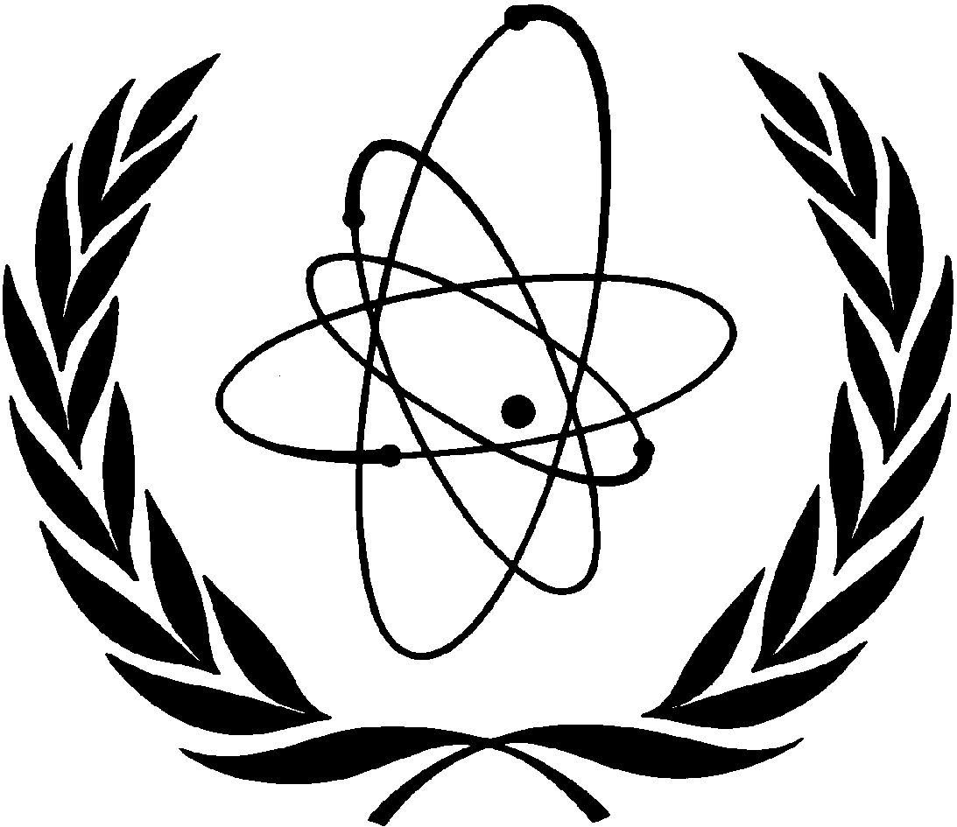
INTERNATIONAL ATOMIC ENERGY AGENCY
Good afternoon, Ladies and Gentlemen,
I am very pleased to be with you today at the University of the Northwest.
I always enjoy meeting students when I travel around the world. The enthusiasm of many young people for science and technology is inspiring.
Science is fundamental for development, and technological advances are a must if we are to tackle the many challenges that face humankind today.
Those challenges include generating enough energy, tackling climate change, producing enough food to provide for a growing world population, and making the benefits of modern health care available to everyone.
The IAEA is active in all of these areas.

We are best known for our work to prevent the spread of nuclear weapons.
For example, the Agency played an important part in helping to bring about an agreement last year between Iran and six major powers plus the EU, known as the Joint Comprehensive Plan of Action. We are now verifying and monitoring Iran’s implementation of its nuclear-related commitments under the agreement.
However, the impact of our work to make nuclear science and technology available to generate electricity, improve human and animal health, and increase food production is significant.
I often summarise our mandate as Atoms for Peace and Development, and that is what I will focus on today.
Ladies and Gentlemen,
South Africa is an experienced user of advanced nuclear technology, a leader in many areas, and a valued partner for the IAEA.
I understand that many of the people who built up your country’s thriving nuclear sector studied at your Faculty of Engineering, here on this campus. Today’s students can take pride in following in their footsteps.
South Africa provides an excellent example of how modern technology can be used effectively to advance development and improve people’s lives. The Agency is proud to be your partner on this journey.
Experts at our headquarters in Vienna, and scientists in our laboratories, are working to help South Africa and other countries tackle their development problems. Countries determine their own development priorities and we provide the necessary assistance.
Let me give you some examples.
We make available something called the sterile insect technique, which is essentially a form of contraception that uses radiation to sterilise male insects that are harmful to crops or livestock.
The males are released into the wild, where they mate with females. No offspring are produced, so the insect population falls.
In South Africa, this technique is being used to combat tsetse flies. We are working with your national experts to establish a sustainable tsetse free zone in KwaZulu-Natal.
The sterile insect technique is used against other pests as well, for example to protect grapes and citrus fruit against fruit flies and the false codling moth.
South Africa actively uses irradiation techniques to prevent fresh food from spoiling. This makes it possible to increase exports of fresh produce to important foreign markets.
Ladies and Gentlemen,
The IAEA has an active programme to improve cancer control in countries which have limited, or no, capacity to offer radiotherapy to cancer patients.
We have invested nearly 300 million euros in cancer and radiotherapy projects throughout the world.
Our Programme of Action for Cancer Therapy – PACT – helps countries to use limited resources efficiently and effectively.
Our work in the medical field in South Africa has included improving quality assurance in radiotherapy centres. In the coming years, our partnership will focus on diagnostic imaging and nutrition.
Ladies and Gentlemen,
On Monday, I had the privilege to visit the iThemba Laboratory for Accelerator Based Sciences, near Cape Town.
I was extremely impressed by the remarkable range of activities, some of which are unique in the southern hemisphere.

They range from neutron and proton therapy for cancers which are difficult to treat otherwise, to the production of radioisotopes which are used in cancer diagnosis and treatment in South Africa and throughout the world. I met some very clever people.
The Labs are partners in many IAEA activities such as accelerator applications and radioisotope and radiopharmaceuticals development.
The IAEA is unique within the UN system in having eight nuclear applications laboratories near Vienna.
They train scientists, support research in human health, food and other areas, and provide analytical services to national laboratories.
More than 150 scientists from South Africa have spent time at the laboratories as fellows or scientific visitors in the last ten years. They work with other top international scientists in their fields and return home to share their expertise with their colleagues.
A comprehensive modernisation of the laboratories is now underway, for which South Africa is providing generous financial assistance. I am especially grateful for the energetic support of your Ambassador, Mr Seokolo, who has lobbied other IAEA countries very successfully to support the modernisation.
Ladies and Gentlemen,
The best known peaceful application of nuclear technology is nuclear power. Many countries see nuclear power as a stable and clean source of energy that can help mitigate the impact of climate change.
The accident at the Fukushima Daiichi nuclear power plant in Japan five years ago put a global spotlight on nuclear safety.
Safety is a national responsibility, but the IAEA brings its 168 Member States together to agree international nuclear safety standards, learn from each other’s experience and provide specialist training.
I have visited many nuclear power plants in the past few years, and in each one, I have seen a strengthening in safety features. The idea that “Safety Comes First” is unchallenged. Nuclear power is now safer, throughout the world, than it was before Fukushima Daiichi.
South Africa makes good use of IAEA services. I am pleased that South Africa has invited the Agency to provide an expert peer review of your regulatory framework for nuclear and radiation safety later this year.
South Africa is the only African country which is using nuclear power at the moment.
But several African nations are among around 30 countries that are considering introducing nuclear power.
It is up to each country to decide whether or not to introduce nuclear power. The IAEA does not attempt to influence countries’ decisions. If they opt for nuclear power, our job is to help them use it safely, securely and sustainably.
We will continue to work closely with South Africa as you expand your nuclear power programme in the coming years.
Ladies and Gentlemen,
Before concluding, I wish to note that South Africa is an excellent role model in terms of South-South cooperation, generously sharing its expertise in the nuclear field with countries on the African continent and beyond.
For example, South Africa provides specialist training and fellowships in cancer treatment to foreign experts. This is helping to bring life-saving treatment to patients who might otherwise have no access to it.
South Africa has been a leader in building up a network of veterinary laboratories known as VETLAB, which helps countries throughout Sub-Saharan Africa to fight animal diseases such as foot-and-mouth disease, avian influenza and Ebola.
South Africa also hosts a number of what we call Regional Designated Centres, which share knowledge and best practice with neighbouring countries in areas as diverse as energy planning, treatment of communicable diseases and managing radioactive waste.
Ladies and Gentlemen,
As I hope I have shown, the safe and smart use of nuclear science and technology has much to contribute to solving many of the major problems facing our planet today.
The IAEA fosters international cooperation in the peaceful use of nuclear science and technology. South Africa, through its active participation in the work of the Agency, is an important contributor to this work.
We attach great importance to our cooperation with South Africa. We look forward to deepening that cooperation in the future.
Many South Africans serve with distinction with the IAEA, including in senior positions.
Perhaps, now that you have learned a little more about the remarkable work of the International Atomic Energy Agency, some of you will be inspired to come and work for us in Vienna. The Agency is a cool place to work.
I will stop here and will be happy to take some questions.
Thank you.

